铸管模系列产品 Pipe Moulds Serials
联系方式：徐 猛 电话：15978718460 传真：0391-6099723 邮箱：zytxumeng@163.com
Contact: meng.xu Telephone: 15978718460 Fax: 0391-6099723 E-mail: zytxumeng@163.com

中原特钢股份有限公司地处河南省济源市，始建于1970年，隶属于中国南方工业集团公司，是中国南方工业集团公司唯一一家专业特殊钢材料生产企业，是以经营大型特殊钢精锻件和以芯棒、石油钻具、铸管模、超高压容器、风机主轴为主的专用装备生产制造企业，尤以生产大型、超长、复杂异形锻件为特长，拥有芯棒、石油钻具、铸管模、风机主轴、瓦楞辊等产品专业生产线，产品广泛应用于石油、机械、冶金、船舶、化工、电力等重大装备制造业。
Zhongyuan Special Steel Co., Ltd is located Jiyuan City, Henan Province, founded in 1970. It is the only special steel manufacturer affiliated to China South Industries Group Corporation (CSGC). With the advantage in producing the large-sized, over-long, shape-complicated forgings, the company has the complete specialized production lines for Mandrel bar, Drilling tools, Pipe Mould for casting machine, super-high pressure vessel, main shaft of wind generators, Corrugator roll and other Precision forgings that are widely applied to petroleum, machining, metallurgy, shipping, chemical, electrical power industry and so on.
中原特钢股份有限公司现有职工4000余人，其中各类专业技术人员1000余人，技术中心为省级技术中心，部分核心技术为国内独有。公司拥有目前国内最大的一条精密锻造生产线,该生产线集炼钢、锻造、机加、热处理于一体，生产手段完善，质保能力强，主要工艺设备2000余台套，目前已形成炼钢25万t（电渣重熔2万t）、锻造15万t、热处理4万t的年综合生产能力。
In our company, there are more than 4000 employees, over 1000 of them are technicians. The technology center is in provincial level and some of the core technologies are only owned by us in China. At present, the production line of precision forging, integrated with steel melting, forging, machining and heat treatment, is the largest one in China. The line contains more than 2000 equipment, with the complete and perfect means of production. The company has the high ability to ensure the product quality. The annual capacity of steel making is 0.25million T (20 thousand T for electroslag remelting), for forging is 0.15million T, for heat treatment is 40thousand T.
公司的管理方针是“遵纪守法，以人为本，顾客至上，优质诚信，节能减排，清洁生产，控制风险，健康安全，预防为主，持续改进”，客户满意是公司永恒的追求。公司未来的发展目标是“国际知名、国内领先”，使命是为客户创造独特价值，为员工创造美好生活，为国家做出突出贡献。公司愿以优质的产品，优良的服务与国内外客户携手共进。
The company administrative policy is: Legal Compliance, People Foremost, Customer First, Good Quality and Faith, Energy-Saving and Emission-Reduction, Clean Production, Risk Control, Healthy and Safe, Prevention First, Continual Improvement. Satisfaction of the customer is our unflagging pursuit. The development goal of our company is to be leader in domestic market and famous in the word. Our mission is providing special value for customers, happy life for workers, and great contribution to our country. With the advantage of our high quality product and excellent service, we sincerely expect to develop business with old and new customers for joint development.

公司自1998年开始生产球墨铸铁管管模，采用YB/T4179-2008、Q/ZTG01-2008企业标准或双方技术协议，可生产材质为15Cr2Mo、21CrMo10、30CrMo等T型水冷金属型管模；S型、N型和K型热模法管模。产品规格为DN80mm~1200mm，长度为3~6m。具有年产各种规格离心球墨铸铁管管模1800支的生产能力。
Since 1998, our company started to produce pipe mould for ductile iron casting machine. The executive specifications are YB/T4179-2008, Q/ZTG01-2008 or technical agreements. We can provide the pipe moulds such as T-tube-type water-cooled metal mold, S-type, N-type and K-type thermal tube molds, which made from the materials 15Cr2Mo, 21CrMo10, and 30CrMo. The product size is DN80mm~1200mm with 3~6m length. The company has the annual capacity of 1800pcs for various kinds of ductile iron pipes.
炼钢采用EBT+LF/VD工艺，锻造经油压机或精锻机一次锻造成型，并按照JB/T1581-96标准进行超声波探伤，管模粗加工（套镗孔）后进行调质热处理和去应力处理，采用数控车床精加工，以满足产品质量要求。
The steelmaking process is EBT+LF/VD and the ingots were forged to the required form once by hydraulic press machine or rotary radial forging machine. The ultrasonic test is carried on according to JB/T1581-96. The pipe mould will be quenched& tempered and performed relieving stress after rough machining (boring), and then the finished machining will be carried out by numerically controlled lathe to meet the quality requirements.
公司生产的铸管模使用寿命与美国、德国进口产品相当，产品销往国内各大铸管生产企业，并出口中亚、南亚、欧洲、北美等地区。
With the same lifetime to those made in America and Germany, our pipe moulds were provided for lots of large manufacturers in China, and were exported to the Central Asia, South Asia, Europe and North America etc.

化学成分(m %)
Chemical Composition (m %)
牌号Grade | C | Si | Mn | Cr | Mo | P | S
15Cr2Mo | 0.12～0.18 | 0.17～0.37 | 0.40～0.70 | 2.30～2.60 | 0.40～0.55 | ≤0.009 | ≤0.009
21CrMo10 | 0.16～0.23 | 0.20～0.40 | 0.20～0.40 | 2.20～2.60 | 0.30～0.50 | ≤0.009 | ≤0.009
30CrMo | 0.23～0.30 | 0.17～0.37 | 0.40～0.70 | 0.80～1.10 | 0.15～0.25 | ≤0.009 | ≤0.009

可根据需方要求控制铅、砷、锡、锑、铋等残余有害元素含量。
The contents of harmful elements, such as lead, arsenic, tin, stibium, bismuth etc. could be controled according to the purchaser requirement.

力学性能Mechanical Property
牌号 Grade | R_{m}（MPa） | R_{p0.2}（MPa） | A（%） | Z（%） | A_{K}（ J） | HBW
15Cr2Mo | ≥780 | ≥680 | ≥12 | ≥50 | ≥78 | ≥230
21CrMo10 | ≥780 | ≥650 | ≥16 | ≥60 | ≥78 | ≥240
30CrMo | ≥780 | ≥680 | ≥10 | ≥35 | ≥21 | ≥200
管模全长布氏硬度差不大于40HBW。The maximum difference of hardness for the full length pipe mould shall be not more than 40HBW.

T型水冷金属型管模结构型式The Structure of T-tube-type water-cooled metal pipe mold
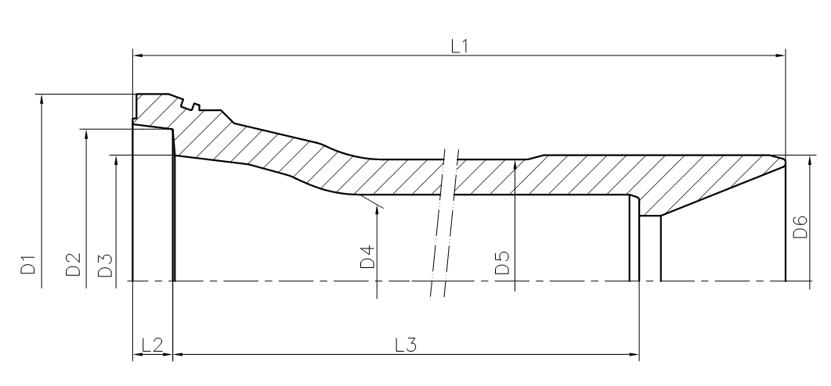

T型水冷金属型管模主要尺寸(mm)
The size of T-tube-type water-cooled metal mold(mm)
管径DN | L1 | L2 | L3 | D1 | D2 | D3 | D4 | D5 | D6 | 重量（Kg）
80 | 6287 | 27 | 6129 | 270 | 205 | 164.7 | 97.2 | 164 | 183 | 530
100 | 6287 | 27 | 6129 | 270 | 205 | 164.7 | 116.8 | 164 | 183 | 400
150 | 6287 | 27 | 6129 | 325 | 266 | 217 | 168.9 | 209 | 209 | 605
200 | 6287 | 27 | 6129 | 385 | 325 | 281 | 221.1 | 261 | 288 | 764
250 | 6287 | 27 | 6129 | 455 | 385 | 336 | 273.4 | 320 | 340 | 1112
300 | 6287 | 27 | 6129 | 520 | 443 | 393.9 | 325.2 | 376 | 387 | 1434
350 | 6341 | 37 | 6169 | 575 | 495 | 448 | 378 | 444 | 450 | 2045
400 | 6341 | 37 | 6169 | 615 | 550 | 502 | 429 | 494 | 502 | 2416
500 | 6341 | 37 | 6169 | 755 | 663 | 606.5 | 532.1 | 608 | 610 | 3557
600 | 6348 | 44 | 6169 | 850 | 790 | 716.1 | 635.3 | 715 | 730 | 4274
700 | 6348 | 44 | 6169 | 970 | 902 | 828 | 738.5 | 828 | 835 | 5838
800 | 6600 | 181 | 6180 | 1148 | 1013 | 948.4 | 843.5 | 940 | 930 | 7269
900 | 6600 | 181 | 6180 | 1258 | 1123 | 1058 | 947.5 | 1063 | 1060 | 9800
1000 | 6600 | 181 | 6180 | 1350 | 1233 | 1165 | 1051 | 1166 | 1160 | 10516

S、N型热模涂料法金属型管模结构型式
The Structure of S-type &N-type thermal tube mold 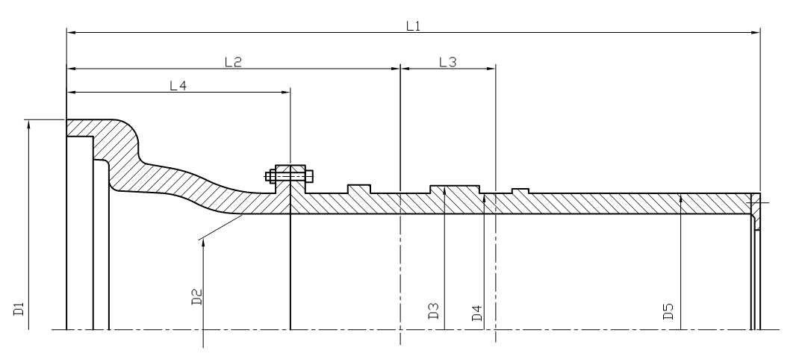

S型、N型热模涂料法管模主要尺寸(mm)
The size of S-type &N-type thermal tube mold(mm)

管径DN | L1 | L2 | L3 | L4 | D1 | D2 | D3 | D4 | D5 | 重量（Kg）
150 | 6270 | 1342 | 200 | 500 | 460 | 170.7 | 320 | 290 | 290 | 2900
200 | 6470 | 1442 | 200 | 500 | 470 | 221.9 | 380 | 350 | 350 | 3128
250 | 6470 | 1475 | 490 | 425 | 613 | 274.4 | 480 | 395 | 395 | 3853
300 | 6505 | 1400 | 490 | 425 | 588 | 328 | 480 | 450 | 450 | 4019
400 | 6505 | 1400 | 490 | 425 | 716 | 429.1 | 580 | 550 | 550 | 4815
500 | 6505 | 1400 | 490 | 425 | 825 | 533.1 | 680 | 650 | 650 | 7213
600 | 6445 | 1475 | 490 | 425 | 982 | 635.7 | 790 | 760 | 760 | 7677

K型管模结构型式
The Structure of K-type Pipe mold
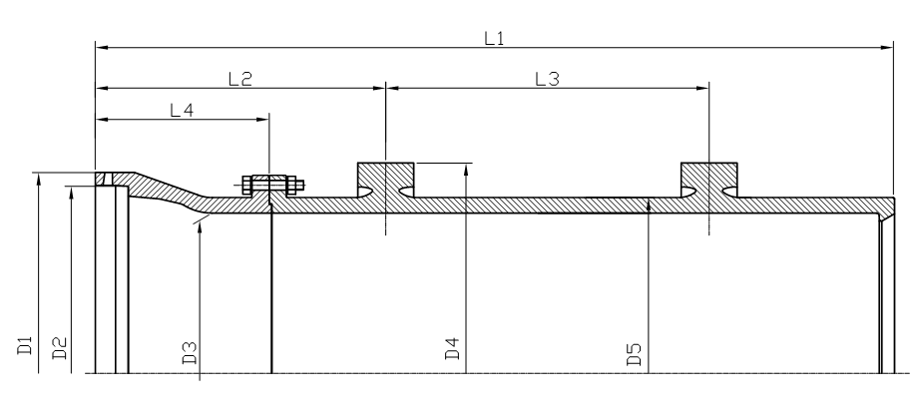

K型管模主要尺寸
The Size of K-Type Pipe Mold

管径DN | L1 | L2 | L3 | L4 | D1 | D2 | D3 | D4 | D5 | 重量（Kg）
1000 | 8545 | 2000 | 4200 | 790 | 1371 | 1231 | 1054.4 | 1540 | 1195 | 21000
1200 | 8545 | 2000 | 4200 | 790 | 1597 | 1447 | 1262.6 | 1540 | 1412 | 25000

参考拔管数量(支)Service Life for Reference(PC)
代号specification | 拔管支数service life | 代号  specification | 拔管支数  service life
DN80～DN100 | ≥4800 | DN450 | ≥2000
DN150 | ≥4400 | DN500 | ≥1880
DN200 | ≥4000 | DN600 | ≥1600
DN250 | ≥3600 | DN700 | ≥1400
DN300 | ≥2600 | DN800 | ≥1200
DN350 | ≥2400 | DN900～DN1200 | ≥1000
DN400 | ≥2000 | DN900～DN1200 | ≥1000

